**ReadMe Documentation**

**Data sources:**

For this project, I did data collection manually. I examined the sources listed below and typed out the relevant information.

* US News
* QS Top universities
* EDUniversal ranking

The links for the sources used in this project are given at the end of the document for reference purposes

**Project Testing:**

The mission for the project is to help students make well-informed selections while choosing courses and to analyze the rankings to build insights for courses through the years by using the University of Maryland course rankings.

**The objectives of our project are to find out the following:**

* To fetch all the programs available at RH Smith Business School which made the top 10 list during the last 5 years.
* To analyze how the course rankings for a particular program evolved over the years.
* To fetch all the programs instructed by the Smith school online.
* To find the programs that are not ranked by any sources.

**Steps to follow to test the project:**

**STEP-1:**

* Firstly, DROP TABLE IF EXISTS statements will be executed. Following that, create 6 tables using CREATE TABLE statements as shown below:
* **Program_T** : The table program defines list of programs and associated attributes
* **ProgramContact_T:** The table has list of contact information for each specific program
* **Source_T**: The list of sources and corresponding URL
* **Ranking_T**: Ranking of particular Program
* **Year_T**: This table consists of year and year term
* **Corresponds_T:** This table consists of rankId and YearId

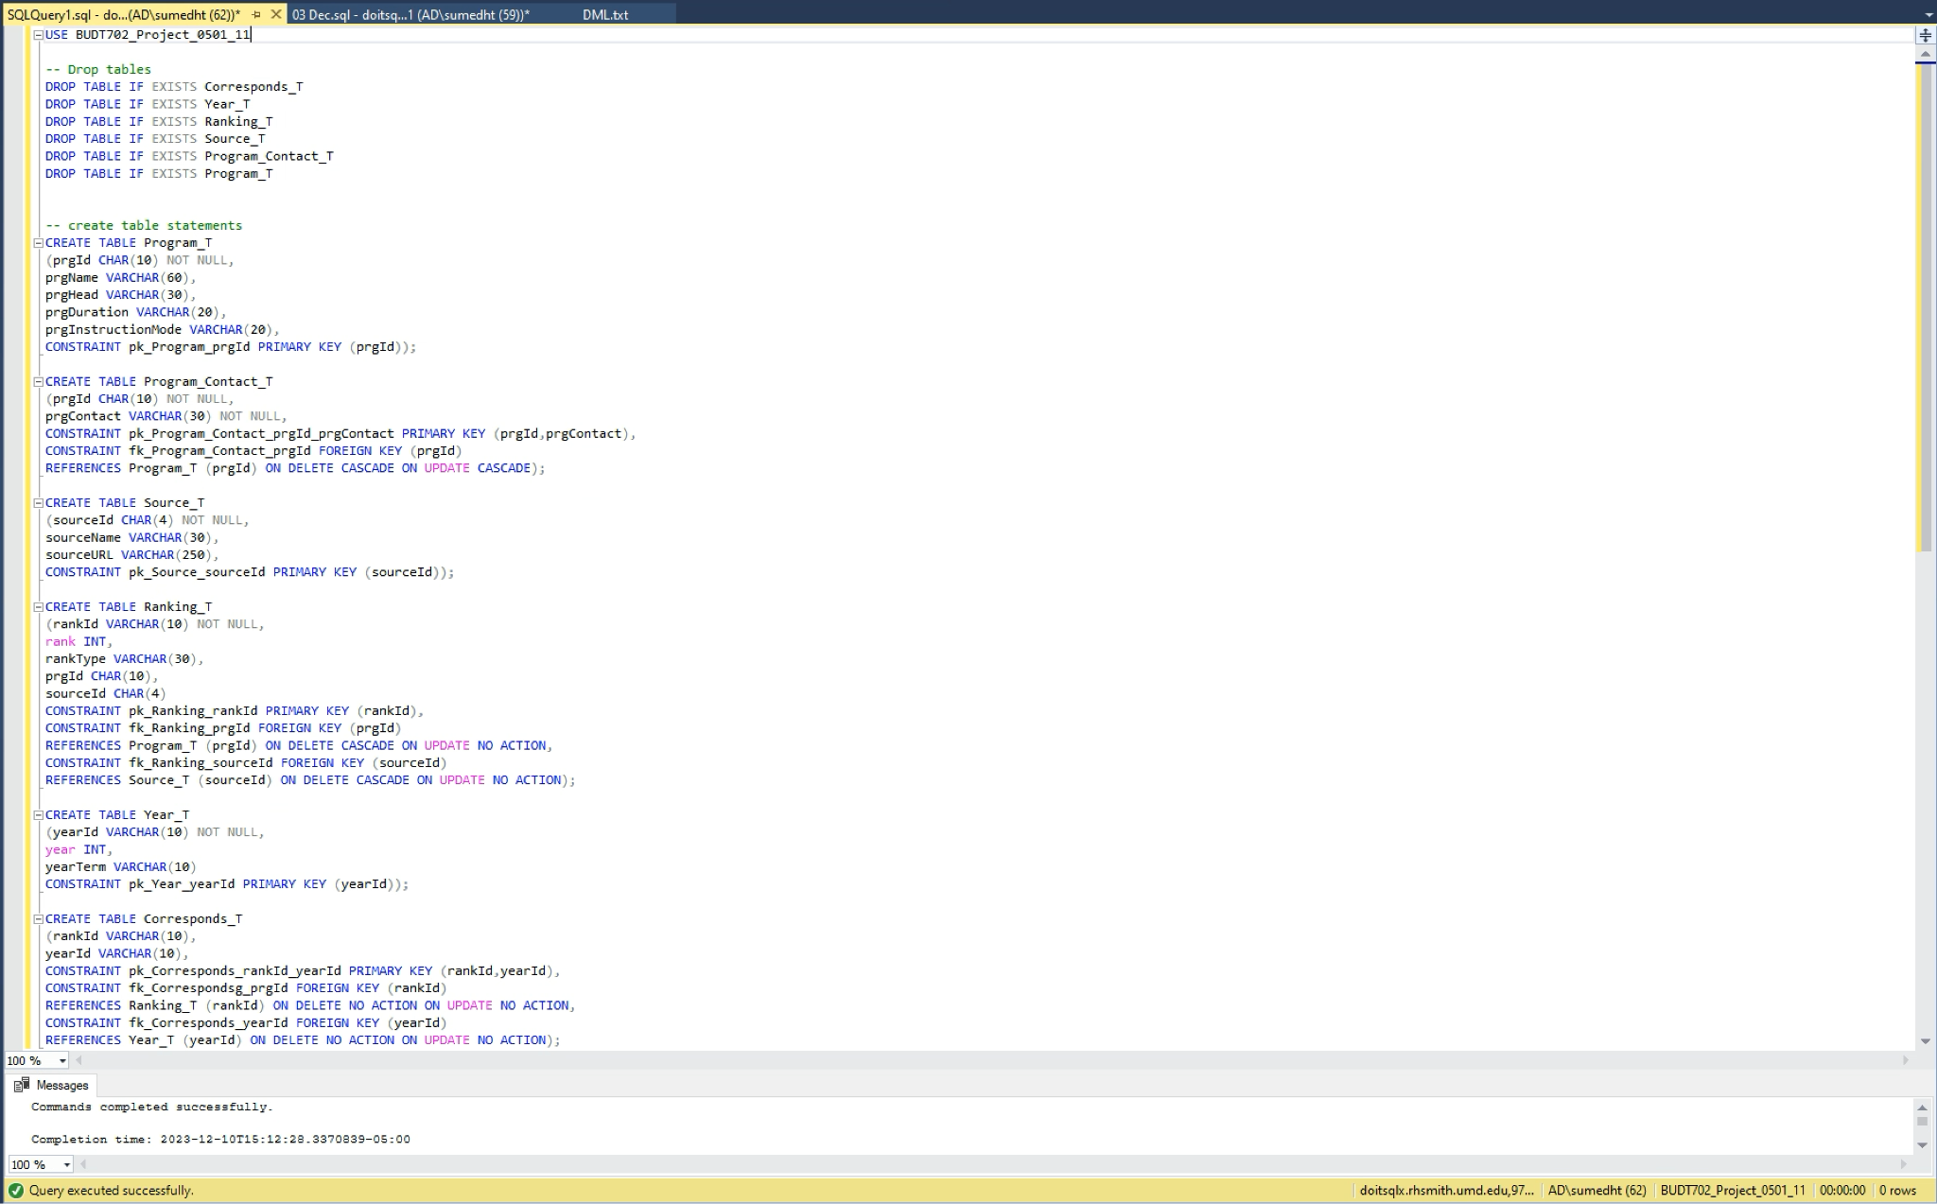

After executing the above statements, the skeleton of tables are created.

**STEP-2:**

1. After the above step, insert values into the tables. For this, we will be executing the following set of INSERT statements.

Insert the following data into Program_T and ProgramContact_T tables.

1. Insert data into Source_T and Ranking_T tables by executing the following INSERT statements.

1. And finally, insert data into the Year_T and the Corresponds_T tables.

1. After inserting all of the information into their appropriate tables, we can perform our SELECT statements using our SQL file Project_DML. These statements will help us achieve our objectives. Beginning with the SELECT statement for the first objective -

**To fetch all the programs available at RH Smith Business School which made the top 10 list during the last 5 years:**

**And the result:**

1. Executing SELECT statement for the second objective -

**To analyze how the course rankings for a particular program evolved over the years:**

**And its output:**

1. Next, we will be executing the SELECT statement for our next objective -

**To fetch all the programs instructed by the Smith school online.**

**Output :**

1. Finally, executing the SELECT statement for our final project objective -

**To find the programs that are not ranked by any sources.**

**Output:**

**References:**

1. <https://www.usnews.com/best-colleges>
2. <https://www.topuniversities.com/universities/university-maryland-college-park/university-maryland-robert-h-smith-school-business>
3. <https://www.best-masters.com/ranking-master-accounting-in-north-america.html>